# Grades vs Learning

* I tried to detect what’s more important? grades or output(learning)
* From a survey that made in 2019 there were a question that Are you more interested in your grades or how much you learn? And these two plots that shows the answers to that question
* Note: - On a scale of 0-10 (where "0" means "Only Grades" ........and "10" means "Only learning")
* We can see that the major is at 10 which is “Only Learning”

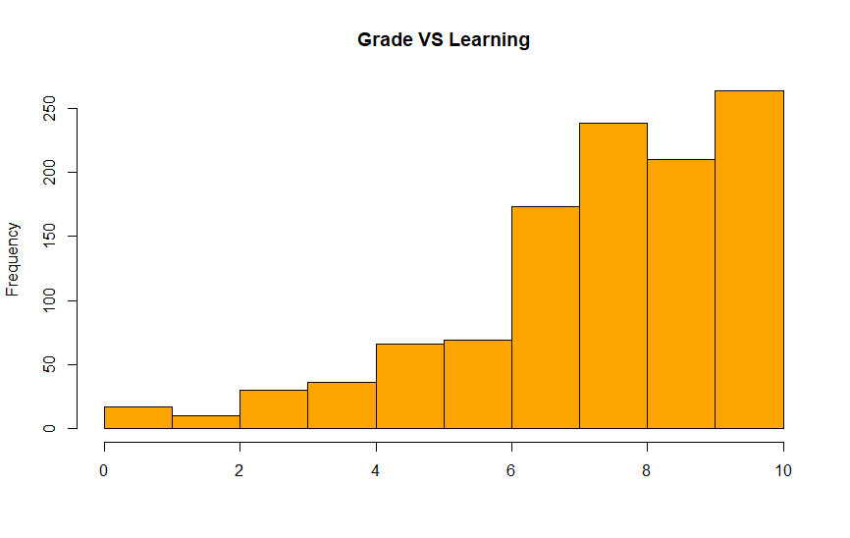

So, I needed to estimate the mean of these data so I use sampling distribution, So I took 100 random samples each of size n = 50 > 30 for each sample I find the mean then I find the mean of means and the figure below shows the histogram which is nearly normal distribution and that make me more confident to the data.

I find that the mean after sample distribution is µ = 7.8 and σ = 0.29

* To become sure that my data isn’t biased and ensure that the gender isn’t one of factors that affect my study I make it on different genders (Men and Women)

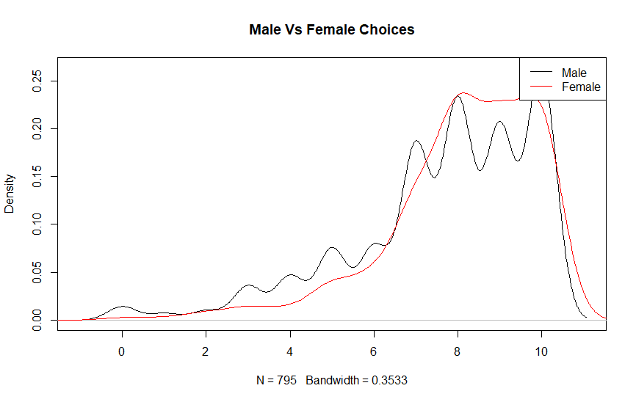

* From previous graph and by applying hypothis test on that graph we can detect that it rejects null hypothesis (There is no relation between gender and Choice) because the p-value is very small so we can reject the null hypothesis
* Not Only that I also made it w.r.t GPAs (Are GPAs affect the choice?) (I think no) to detect whether the bad GPAs was one from reasons that students take their opinions on, or their choice based on their decision not because of low GPA

* From that graph and by performing hypotheses test we can reject null hypothesis (There is no relation between GPAs and Choice) because the p-value was very small.
* What about the mean of the choices (Is it greater than 7 or not ?!) by applying hypotheses test: -

Null hypothesis can’t be rejected because the value of p is greater than 0.05

# Conclusion

* The choice of learn or grades clearly doesn’t depend on the gender or on the GPAs
* Grades are short term important, while knowledge is long term important. Grades matter at certain times and are essential to making bigger steps in your academic path. Knowledge matters consistently through time, and helps you get good grades, but knowledge is also an authentic reflection of your genuine learning.